Japanese Woodblock Print Workshop
with Mary Brodbeck

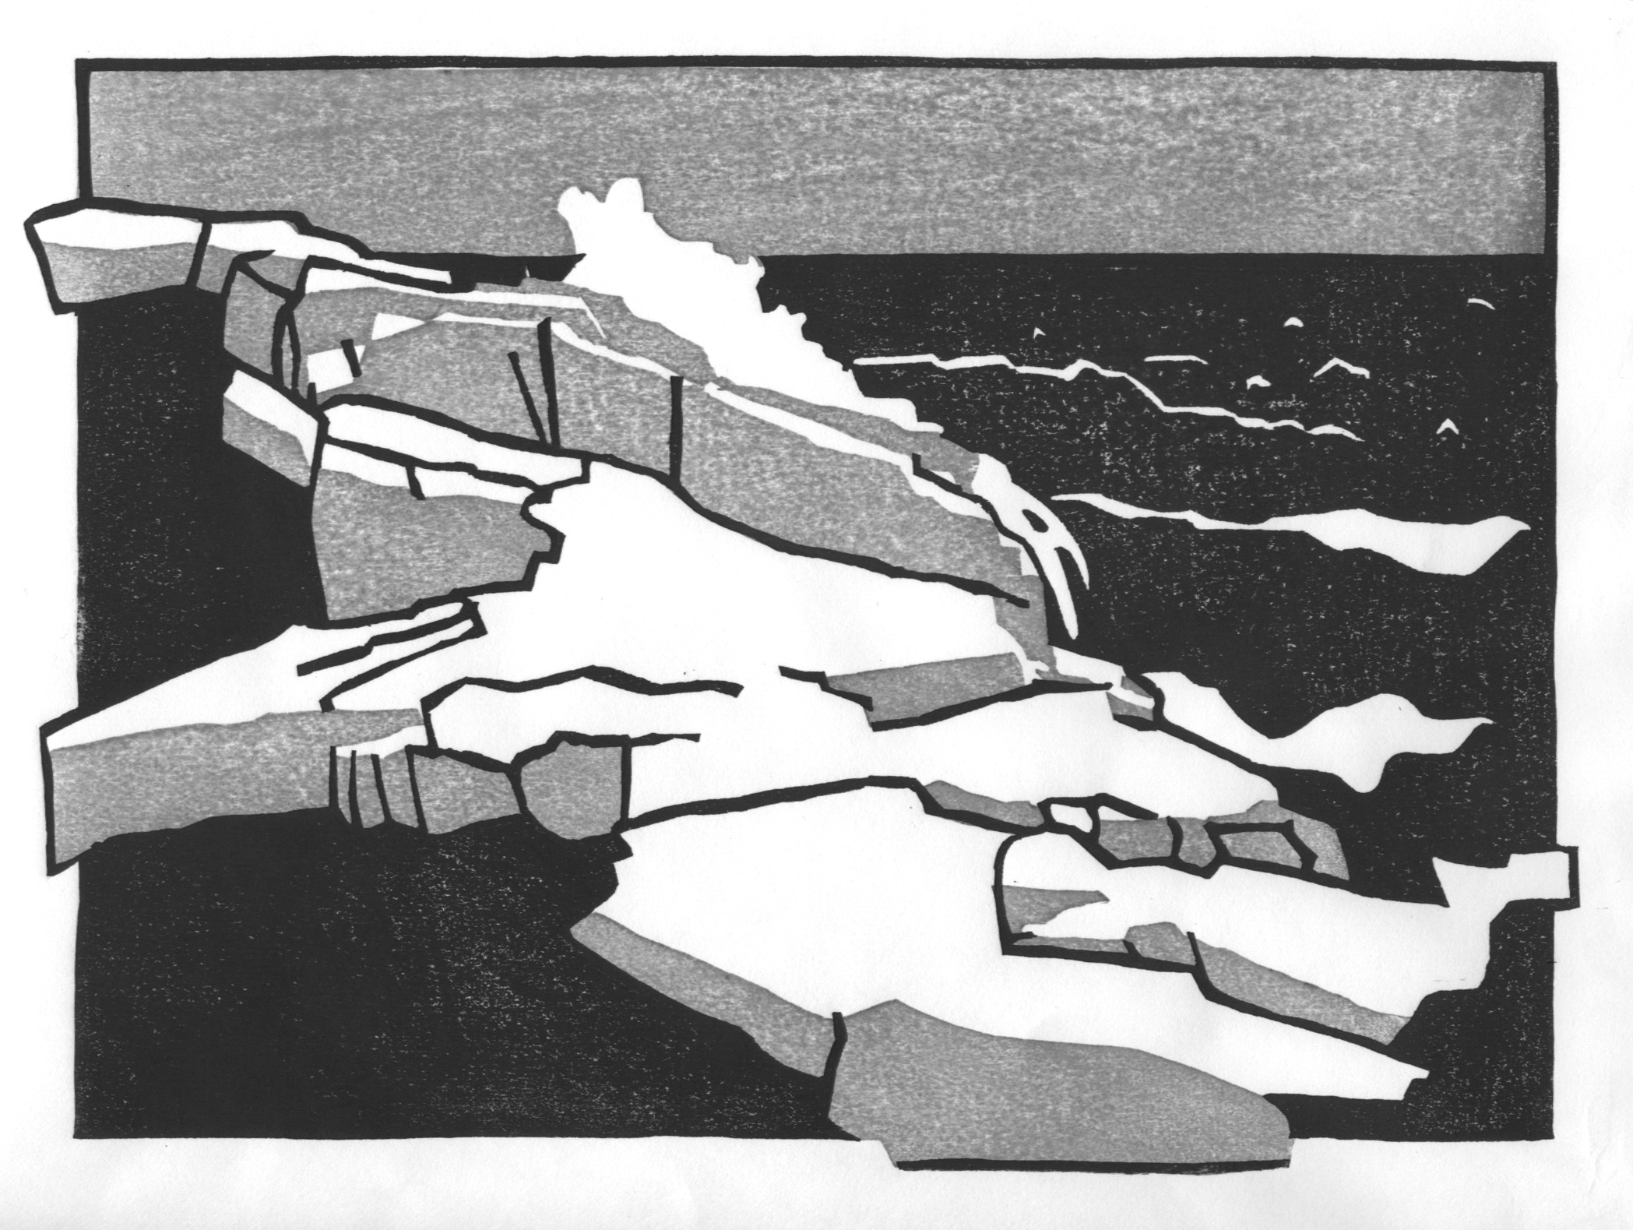
Sample Image of Final Print

Step One – Create Pattern

Create (two color) design onto 9” x 12” tracing paper within a 7” x 10” boundary outline. This pattern will be the full scale of your finished print and will be the drawing used to transfer your two-color design onto the blocks. Try to keep your design simple. Think in terms of shapes (verses lines).

Paper Size 9” x 12””

Image Size 7” x 10”

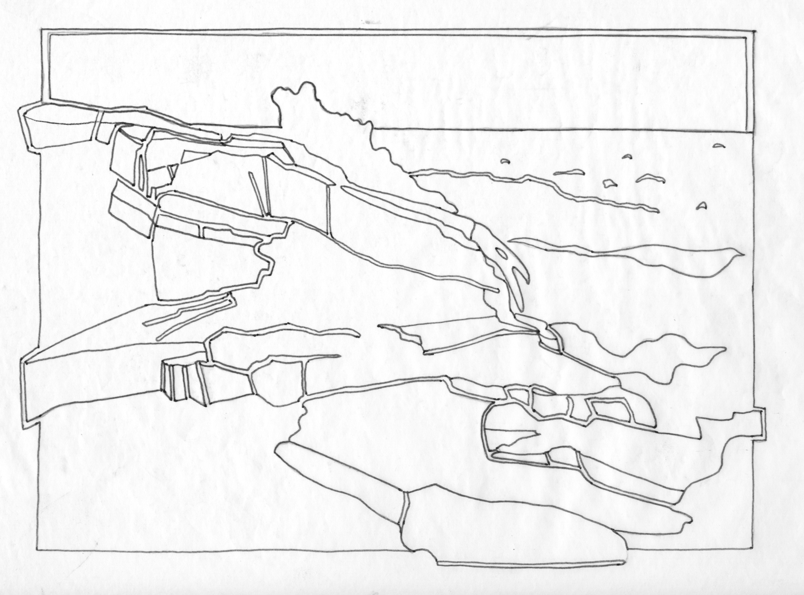
Pattern

Step Two – Make three photocopies of pattern

Photocopy 1 Photocopy 2 Photocopy 3

Step Three – On one photocopy (can also use tracing paper overlays), create a two-color render using colored pencils. One color should be dark (black is easiest) and the second color should be a medium value (could be gray).

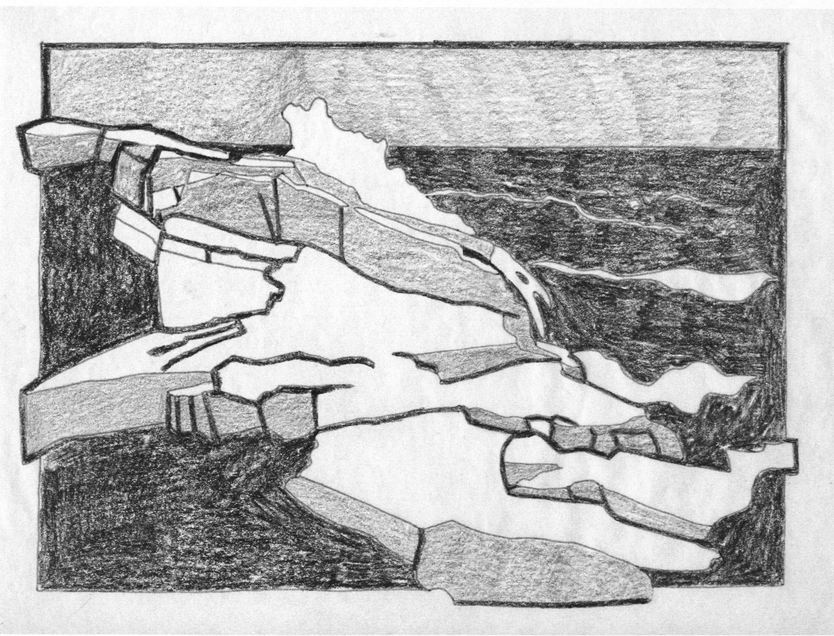
Render the complete colors of your print on photocopy 1

Step Four – Deconstruct the rendering into its separate color components. These will be your notes for how to layout the colors onto the separate blocks. You will use your pattern and carbon paper for laying out the design on the block. These photocopies are your notes only.

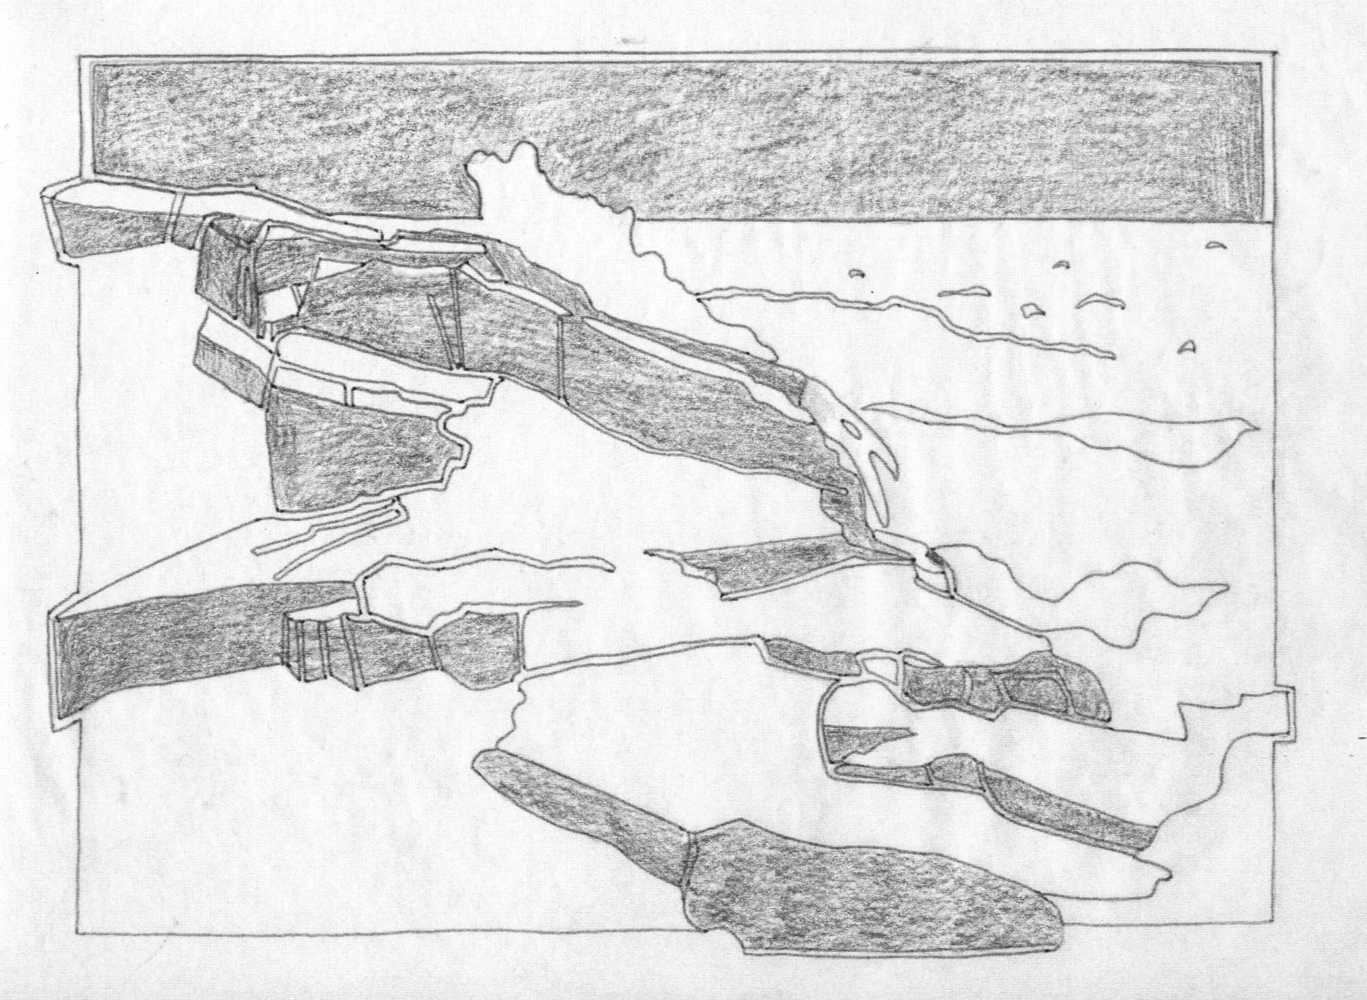

Sketch the light color on photocopy 2

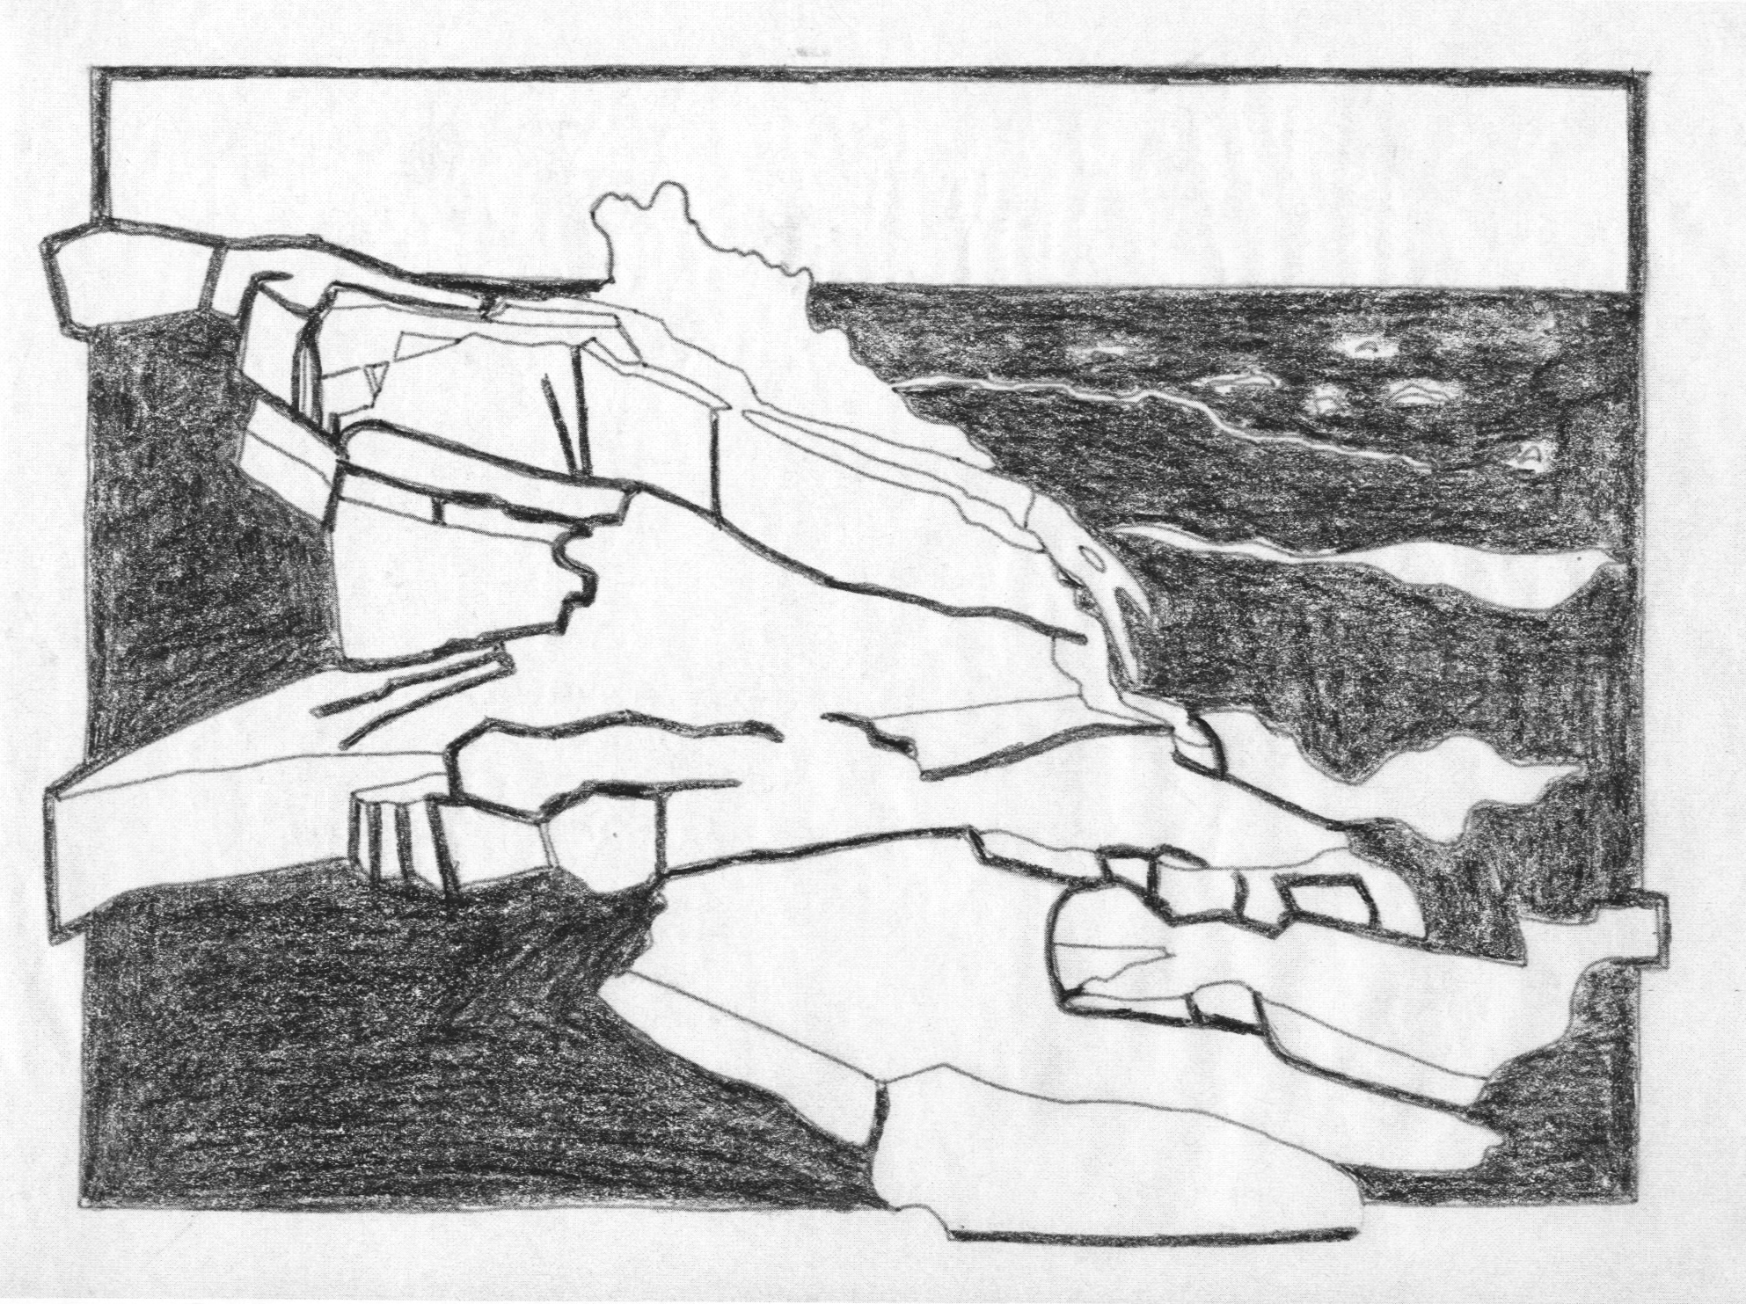
Sketch the dark color on photocopy 3

These will be your notes for how to lay out the separate colors onto the blocks.

